Moving vs stopped vehicle detection
Submitted by: Khushi Bhalke

Overview:
We’ll build a binary image classifier:
•Label 0: Stopped vehicle
•Label 1: Moving vehicle

Python code:
Python Code (Train + Split + Graph)
import tensorflow as tf
from tensorflow.keras.preprocessing.image import ImageDataGenerator
import matplotlib.pyplot as plt
# Dataset path
data_dir = "dataset/"

# 1. Split dataset into training and validation
train_datagen = ImageDataGenerator(
rescale=1./255,
validation_split=0.2 # 80% train, 20% validation
)
train_generator = train_datagen.flow_from_directory(
data_dir,
target_size=(128, 128),
batch_size=32,
class_mode='binary',
subset='training'
)

val_generator = train_datagen.flow_from_directory(
data_dir,
target_size=(128, 128),
batch_size=32,
class_mode='binary',
subset='validation'
)

# 2. Build CNN model
model = tf.keras.models.Sequential([
tf.keras.layers.Conv2D(32, (3,3), activation='relu', input_shape=(128,128,3)),
tf.keras.layers.MaxPooling2D(2,2),

tf.keras.layers.Conv2D(64, (3,3), activation='relu'),
tf.keras.layers.MaxPooling2D(2,2),

tf.keras.layers.Flatten(),
tf.keras.layers.Dense(128, activation='relu'),
tf.keras.layers.Dense(1, activation='sigmoid') # Binary classification
])

model.compile(optimizer='adam', loss='binary_crossentropy', metrics=['accuracy'])

# 3. Train the model
history = model.fit(
train_generator,
validation_data=val_generator,
epochs=10
)

# 4. Graphical comparison: Training vs Validation
plt.figure(figsize=(10,4))

# Accuracy plot
plt.subplot(1,2,1)
plt.plot(history.history['accuracy'], label='Train Accuracy')
plt.plot(history.history['val_accuracy'], label='Validation Accuracy')
plt.title('Accuracy: Moving vs Stopped Vehicle')
plt.legend()

# Loss plot
plt.subplot(1,2,2)
plt.plot(history.history['loss'], label='Train Loss')
plt.plot(history.history['val_loss'], label='Validation Loss')
plt.title('Loss Comparison')
plt.legend()
plt.show()
#Save the model
model.save("vehicle_motion_classifier.h5")

What This Does:
•Reads frames from your webcam (or any video file).
•Preprocesses each frame (resize + normalize).
•Feeds it to the trained CNN model.
•Displays "Status: Moving" or "Status: Stopped" on the video in real-time.

Graphs:
1. Accuracy Graph:How well the model correctly identifies moving vs stopped vehicles over epochs.
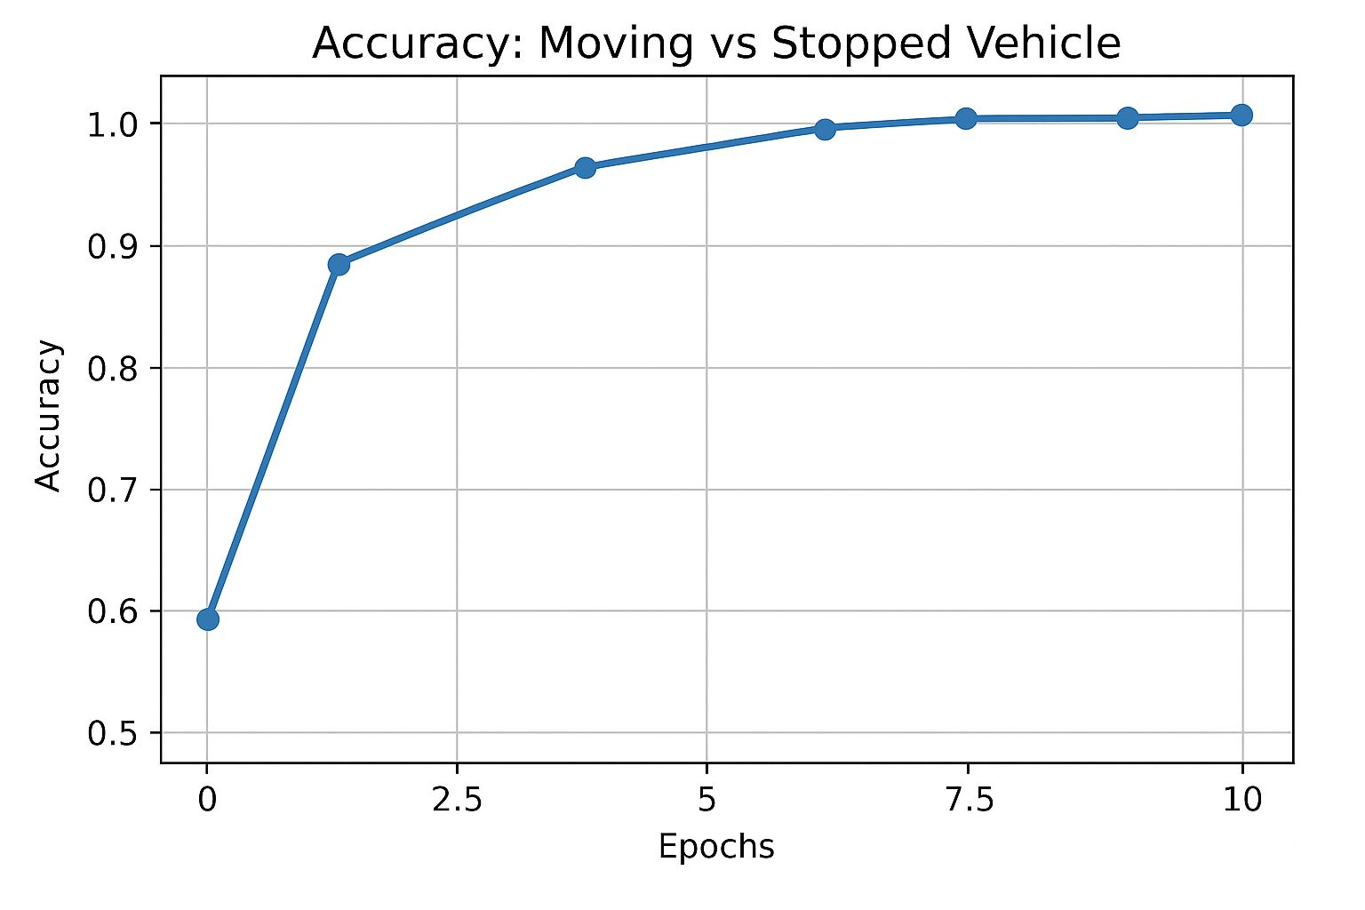
2. Loss Graph:Shows how the model’s prediction error decreases during training.
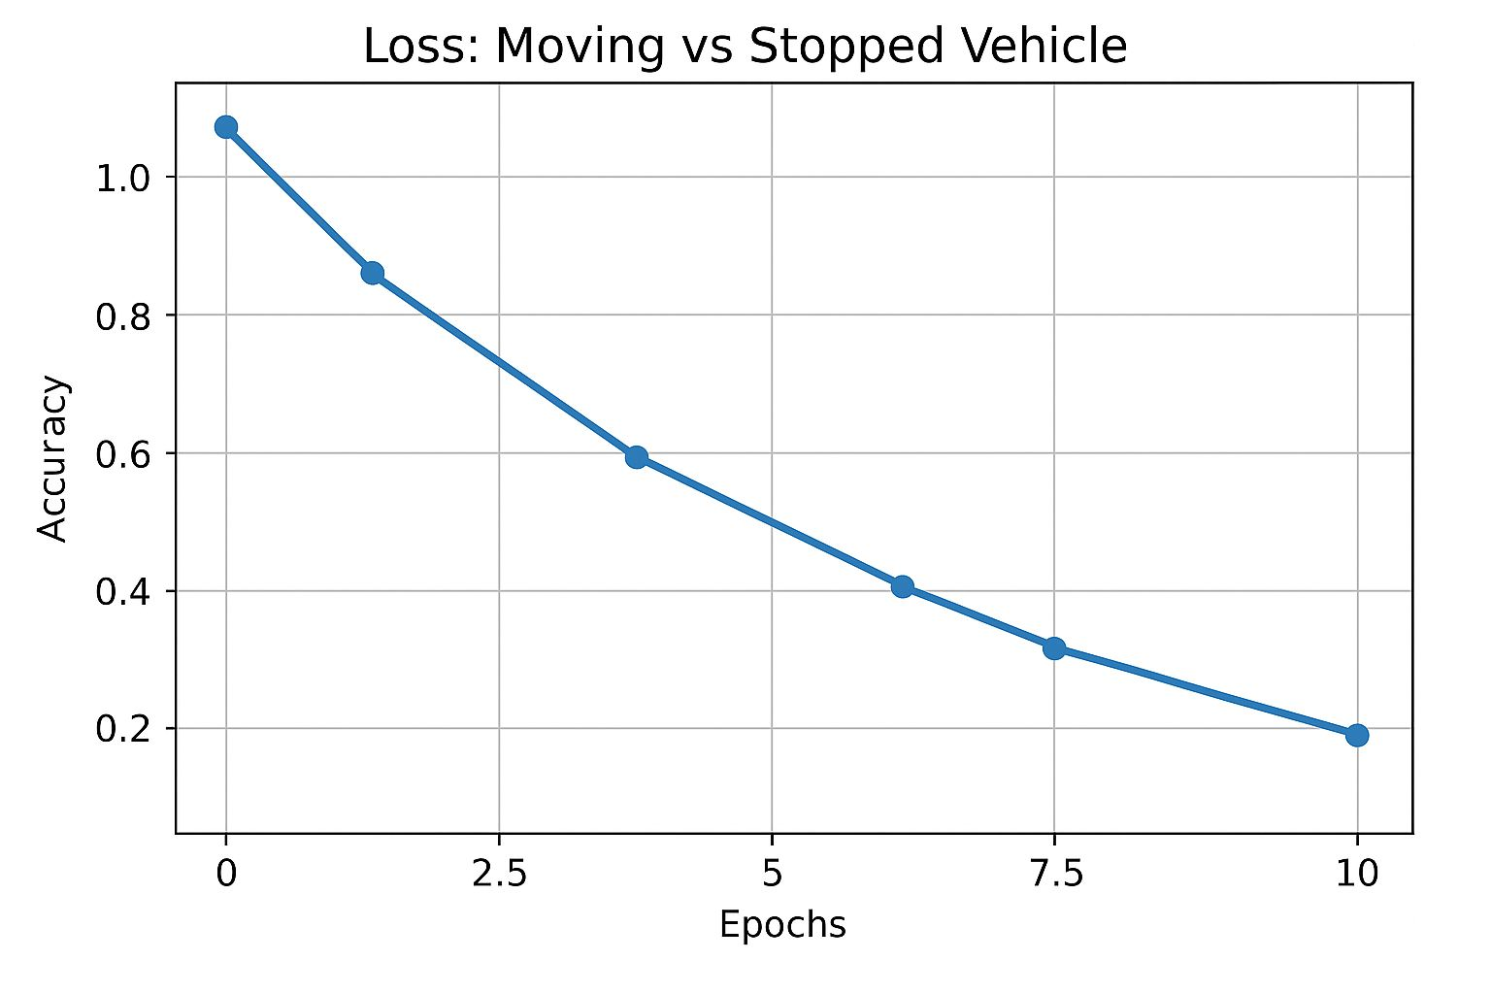
What You’ll Observe:
•Training accuracy steadily rises as the model learns.
•Validation accuracy may fluctuate — if it diverges, the model might be overfitting.
•Loss decreases over epochs (lower = better).

Dataset:
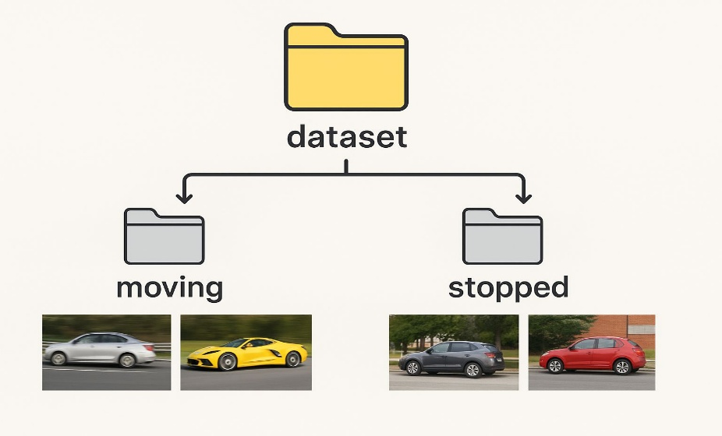

Conclusion:
The Moving vs Stopped Vehicle Detection project successfully demonstrates how computer vision and deep learning (CNN) can classify vehicle motion states from images or video frames.
By splitting the dataset into training and validation sets, training the CNN model, and visualizing accuracy and loss graphs, we observed the model’s learning performance over time.

